**CSCI 3260 Course Project Report**

Group Member:

HUANG Chuanshan 1155076957

Shen Yu-Tang 1155070292

1. **Overall Scene**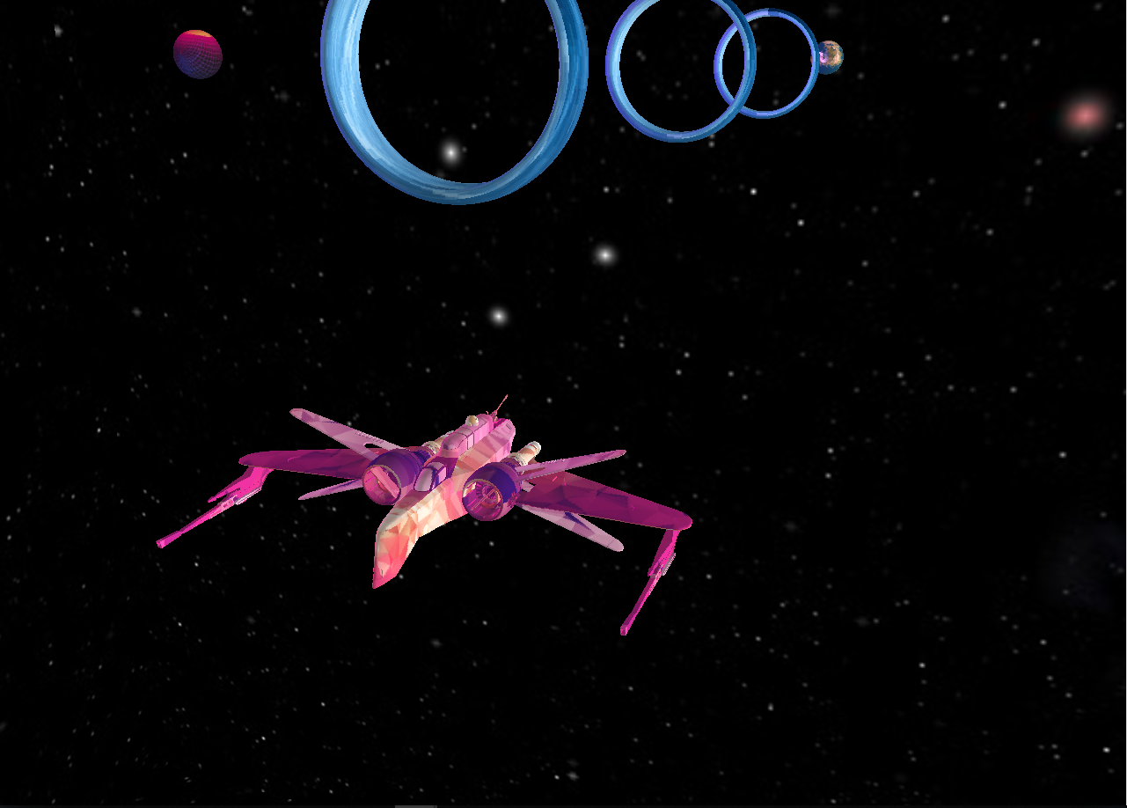
2. **A closer look at each object**
   1. 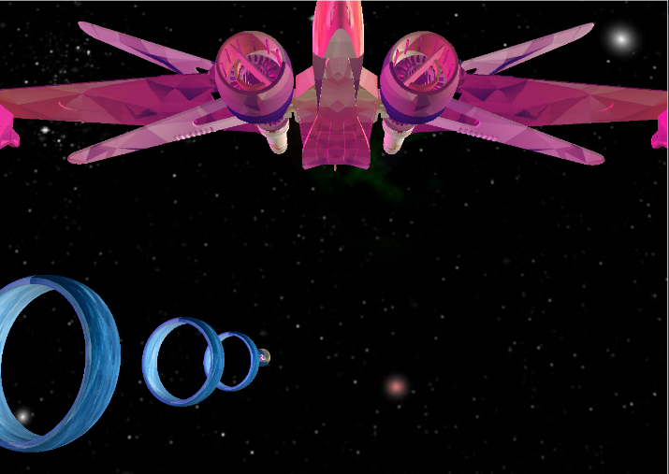The spacecraft
   2. The Ring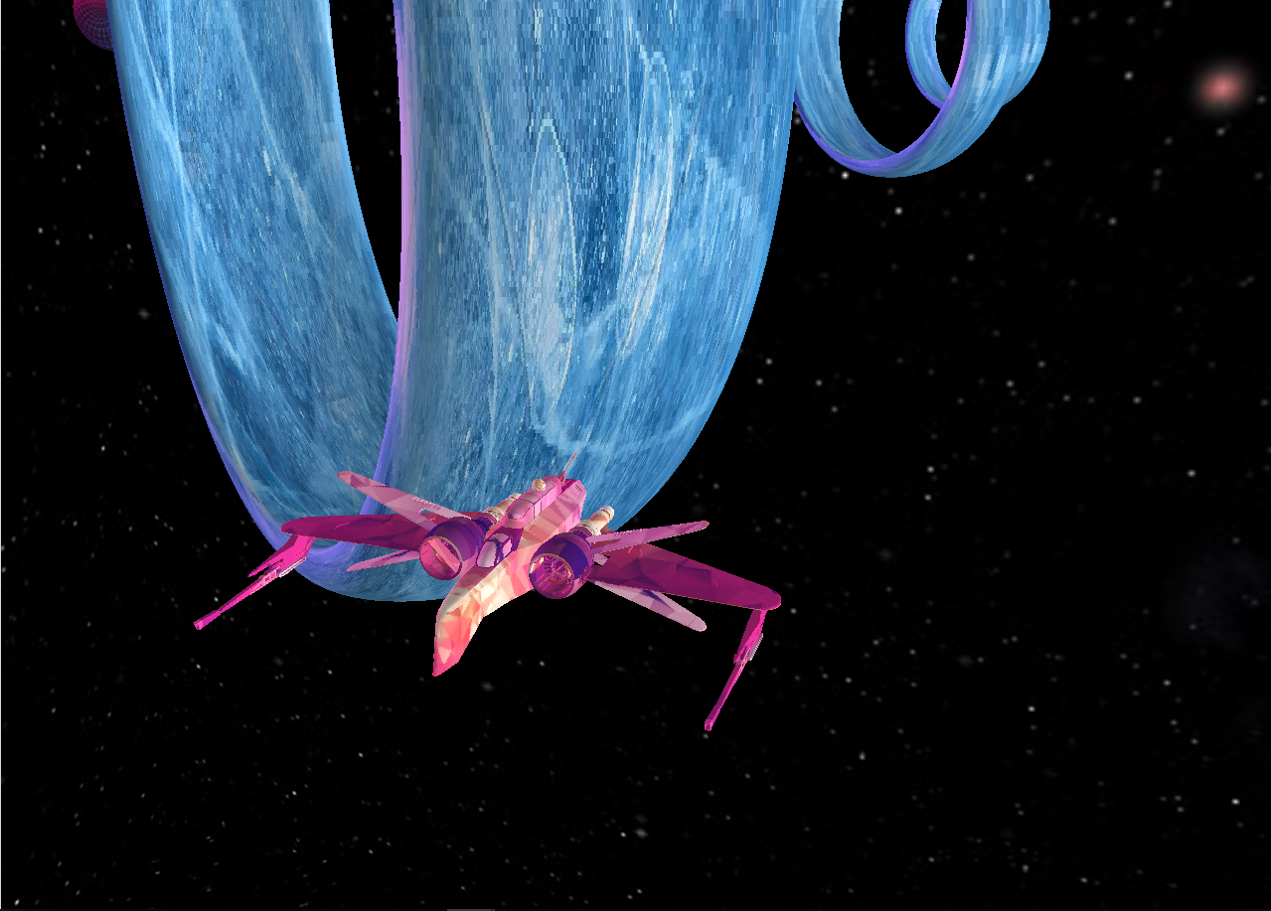
   3. The Wonder Star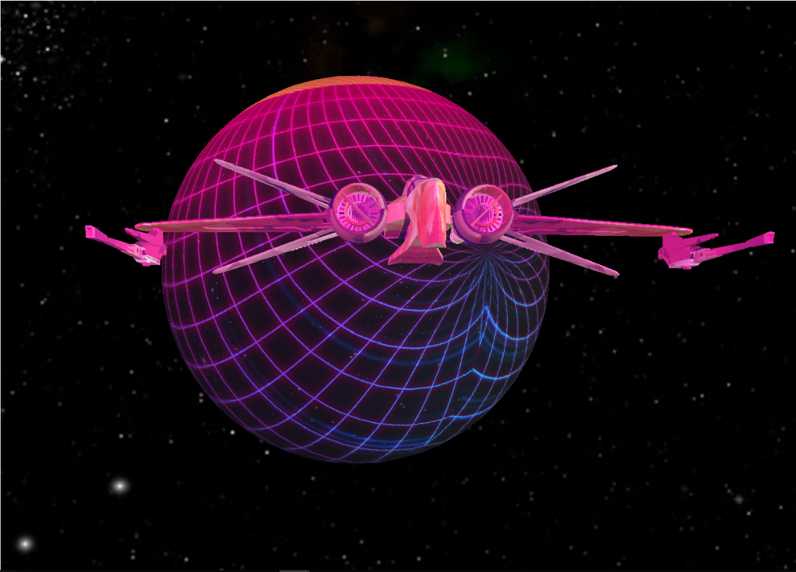
   4. The Earth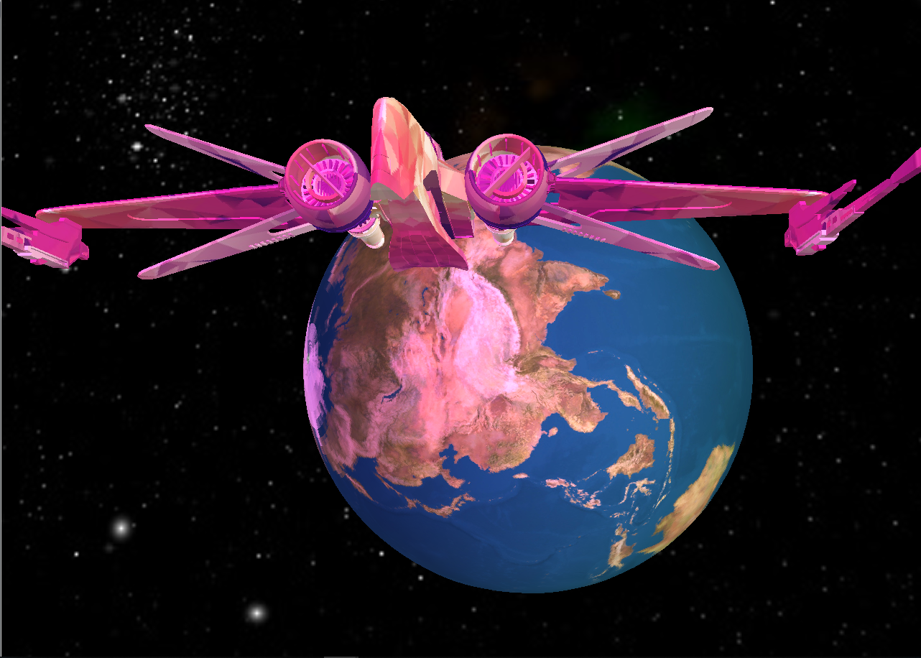
3. **Effects Showreel**
   1. Turning green while passing a ring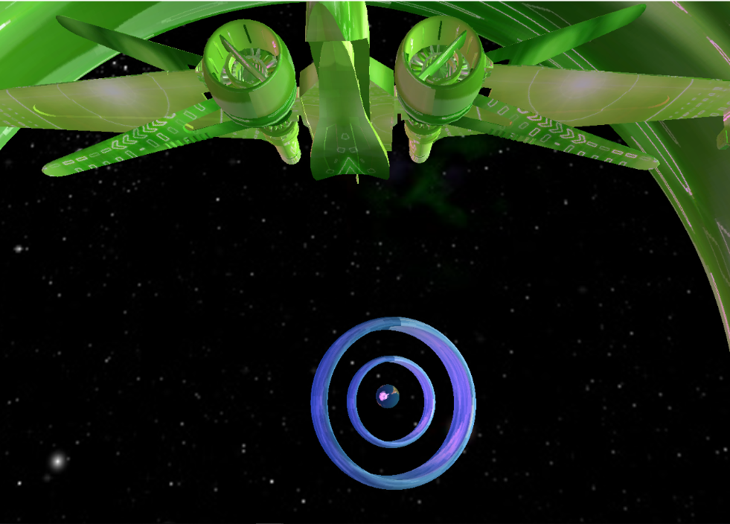
   2. Collision detection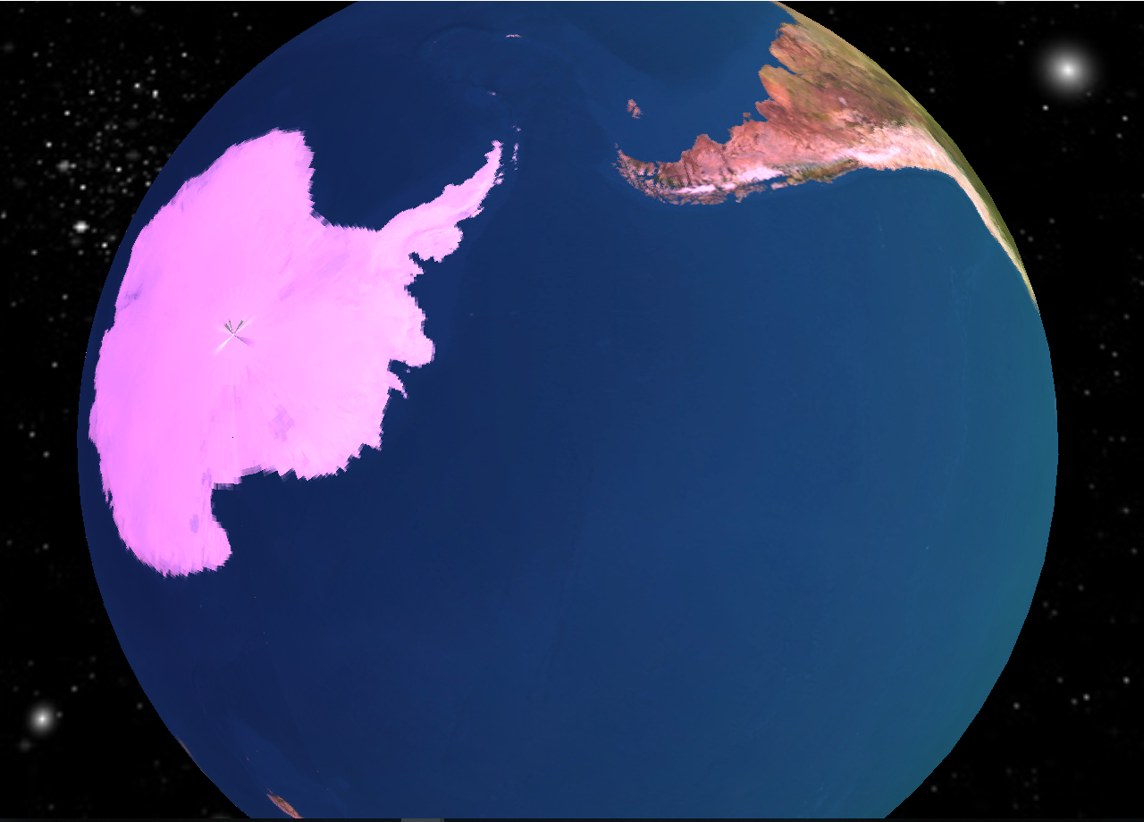
   3. A second light source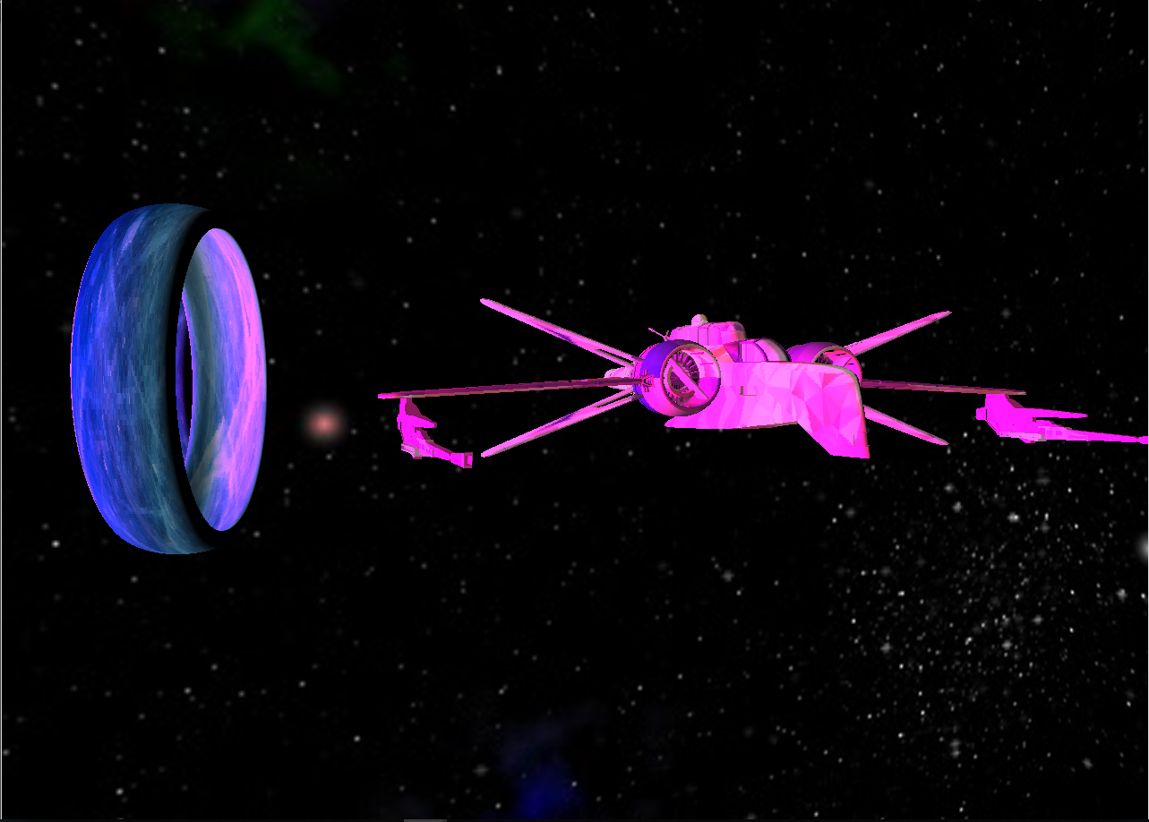To illustrate, the first light source gives out white light, while the second one sheds magenta light. The above image is shot when the first light source is turned off.
4. **Brief explanation of our implementation**
   1. Loading objects and textures are done as in Assignment 2.
   2. To render a skybox, I rewrite the *loadBMP_custom()* function such that it takes in an iterator (0 to 5) to recursively pass the six faces of a cubemap to OpenGL. The remaining codes are the same as texture mapping.
   3. Following the logic in tutorials, I calculate the distance between the spacecraft and the target object to achieve collision detection and turning-to-green. For the turning-to-green effect, I simply map another green texture to the spacecraft and target object when they are close enough.
   4. For the viewing perspective, I calculate a *cameraFront* vector that the camera should point to and then insert into *glm::lookAt()* function.
5. **Interactive control interface**
   1. Arrow keys to move the spacecraft around
   2. Move the mouse to toggle viewpoint
   3. ‘q’, ‘w’, ‘e’, ‘r’ are used to adjust the diffuse lighting of both light sources
   4. ‘z’ and ’x’ are for changing the specular intensity of light source 1 (the white one)